Cambridge Central European Conference 2019:
Post-1989 Transformation and Historical Memory

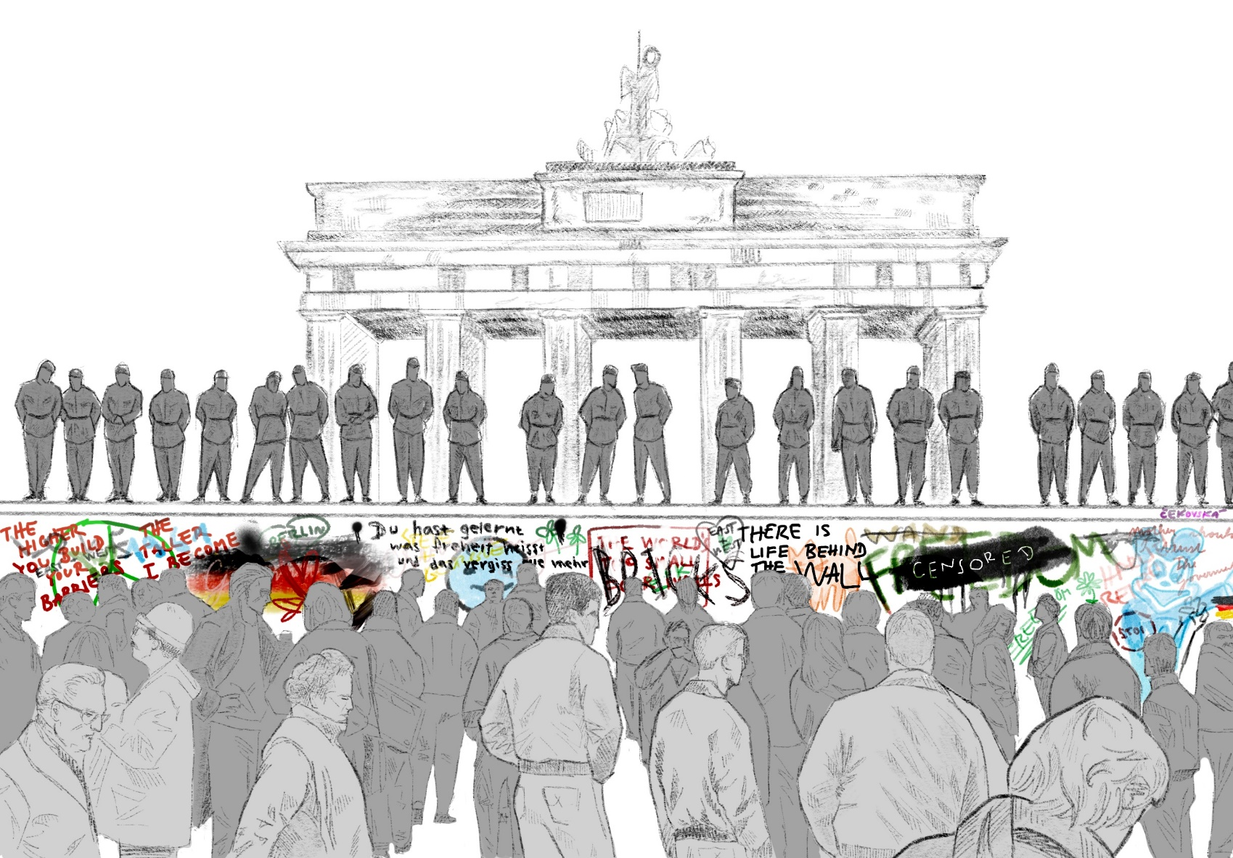

Date: 2nd November 2019
Venue: Frankopan Hall, Westcourt, Jesus College, 22 Jesus Lane, CB5 8BJ Cambridge
The year 2019 represents the 30th anniversary of the 1989 revolutions, which reshaped both the international and domestic landscape in Central and Eastern Europe, leading to a large-scale political, economic and social transformation. The 30th anniversary provides a good opportunity to look back at these processes.
The Cambridge Central European Conference 2019: Post-1989 Transformation and Historical Memory will focus on the historical milestone of 1989, and assess from a multi-disciplinary perspective the experiences of five countries in Central Europe: Germany and the four countries of the Visegrad group – the Czech Republic, Hungary, Poland, and Slovakia. While each of them faced different challenges - such as, for instance, German reunification and the Czechoslovakian “Velvet Divorce” - they are all member states of the European Union with new challenges and opportunities in the offing. To offer a variety of disciplinary and case study perspectives, the conference aims to bring together researchers from academic institutes from the region, as well as actors who were involved in the transformation processes first-hand.
http://www.cceconference.co.uk/
Programme
9:00 Registration
10:00 Opening
Confirmed: H.E. Lubomir Rehak, H.E. Arkady Rzegocki, Dr. Harald Wydra
11:00 – 13:00 Panel I – Historical Memory of 1989 in Central Europe
Confirmed: Prof. Samuel Abraham, Prof. Kerstin Brueckweh, Prof. Constantin Iordachi, Dr. Hubertus Jahn (chair), Dr. Oldrich Tuma, Dr. Piotr Wcislik
13:00 – 14:00 Lunch
14:00 – 16:00 Panel II – Post-1989 Transformation in Central Europe
Confirmed: Dr. Michal Horacek, Dr. Balint Magyar, Mr. Janusz Onyszkiewicz, Dr. Brigita Schmognerova, Dr. Harald Wydra (chair)
16:00 Closing Keynote Speech
Confirmed: Dr. Jana Howlett
16:30 – 18:00 Reception
Reception Venue: Round Church, Bridge Street, CB2 1UB Cambridge

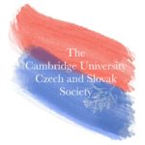
Organisers:

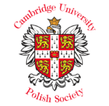

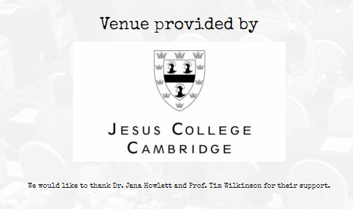
Partners:

